**High Pressure Detection System Report**

**Embedded Systems Online Diploma**

**Eng. Mahmoud Essam Mahfouz**

[**Progress Page**](https://www.learn-in-depth.com/online-diploma/mahmoud1mahfouz%40gmail.com)

**6/12/2022**

# **System Requirements :**

1. The System Shall Measure the pressure through a pressure sensor
2. If the pressure value is greater than threshold system will inform the crew
3. The system will inform the crew threw a led that will on for 60 seconds

## **Requirement Diagram**

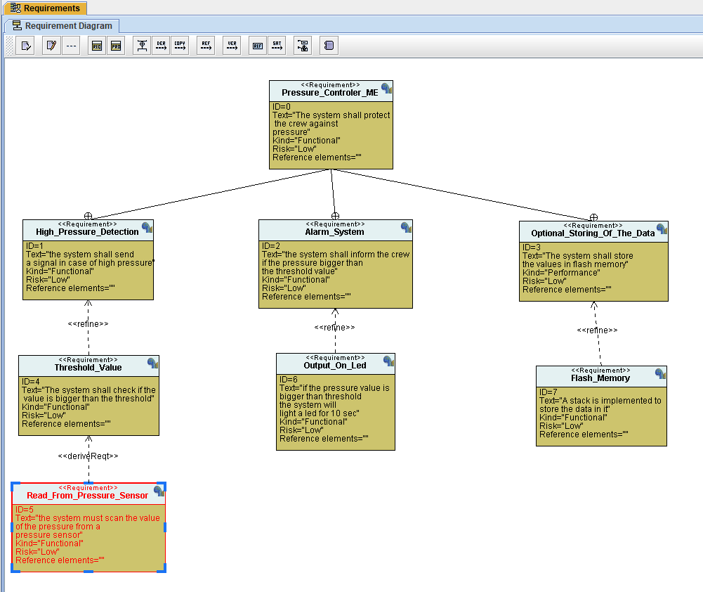

# **System Analysis :**

## Use Case Diagram

## Sequence Diagram

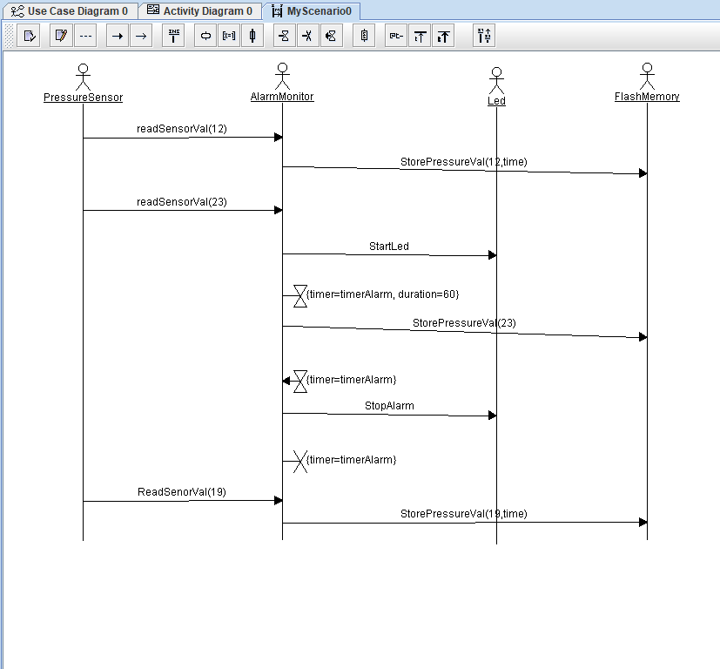

## Activity Diagram

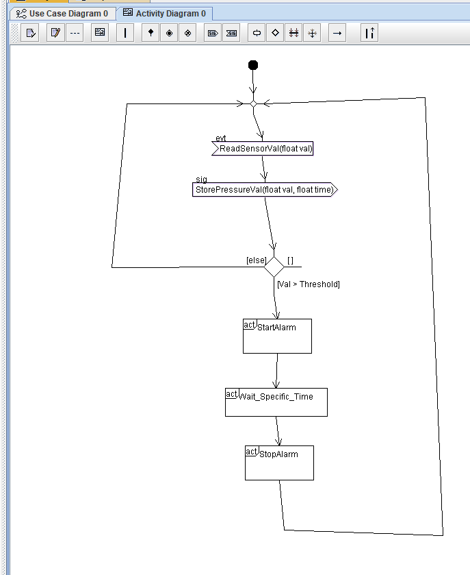

# **System Design**

## System Modules

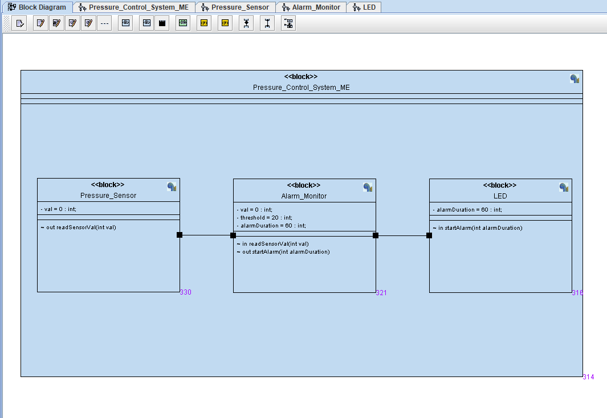

### Pressure Sensor Diagram

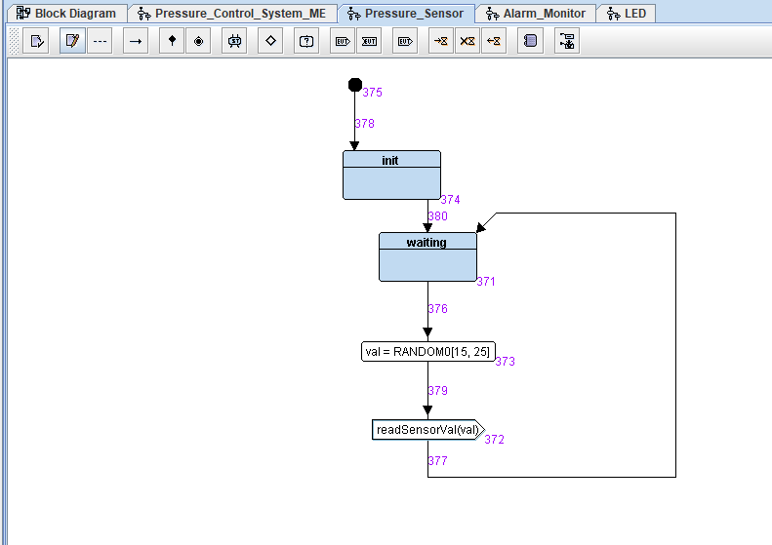

### Alarm Monitor Diagram

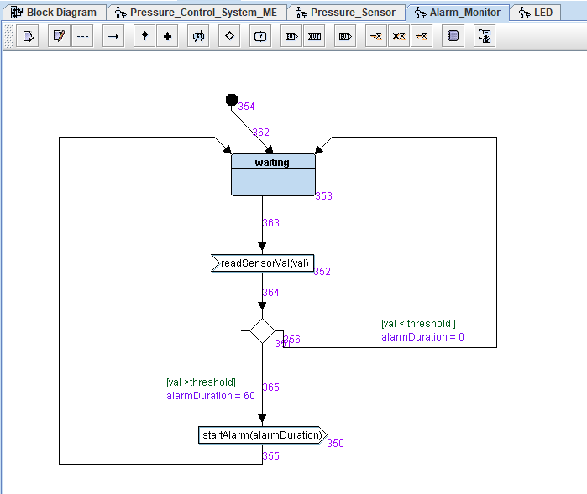

### Led Diagram

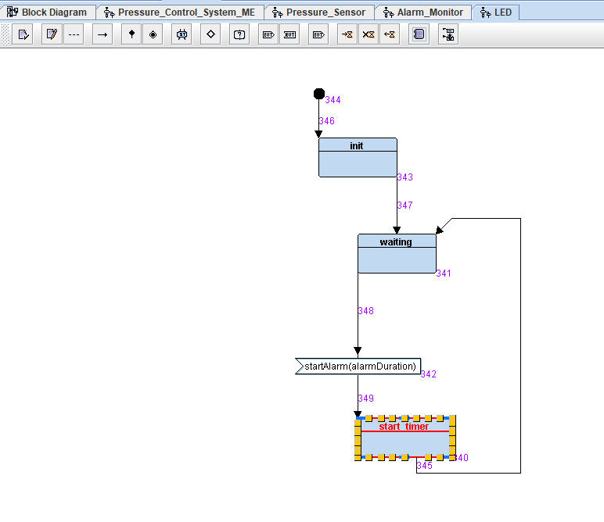

# **Simulation**

## **Diagrams Simulation**

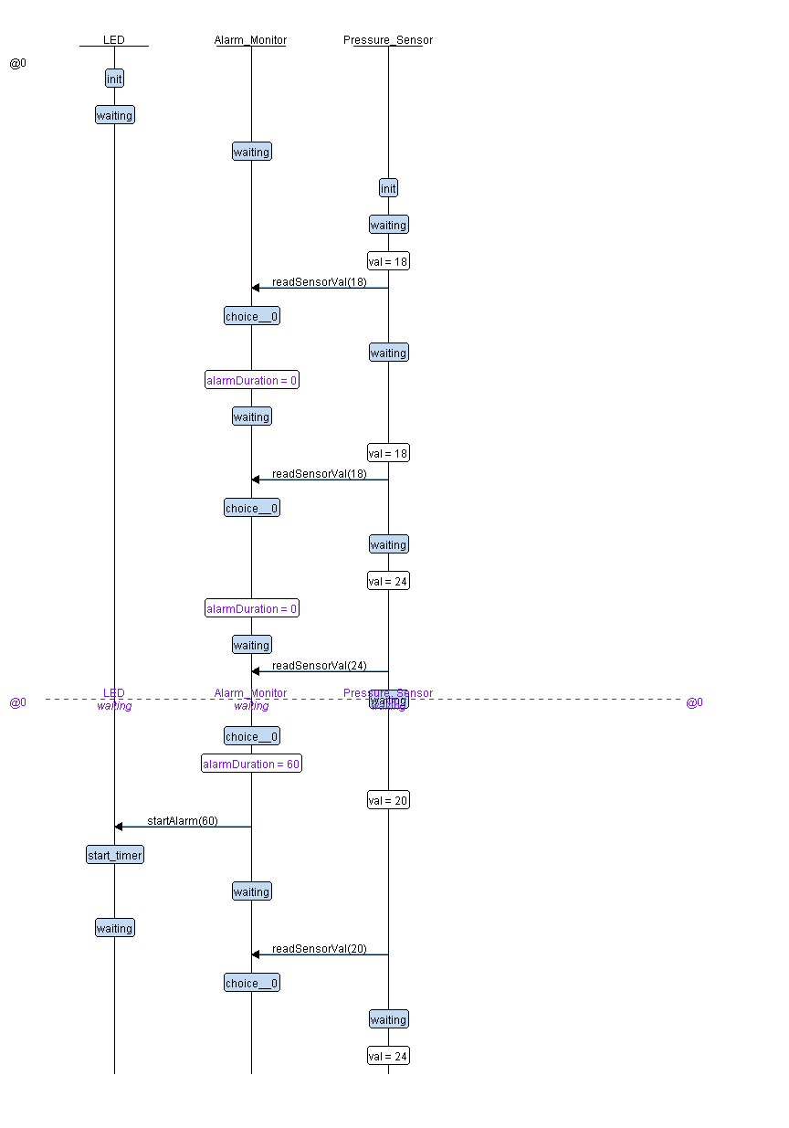

## **Protues Simulation**

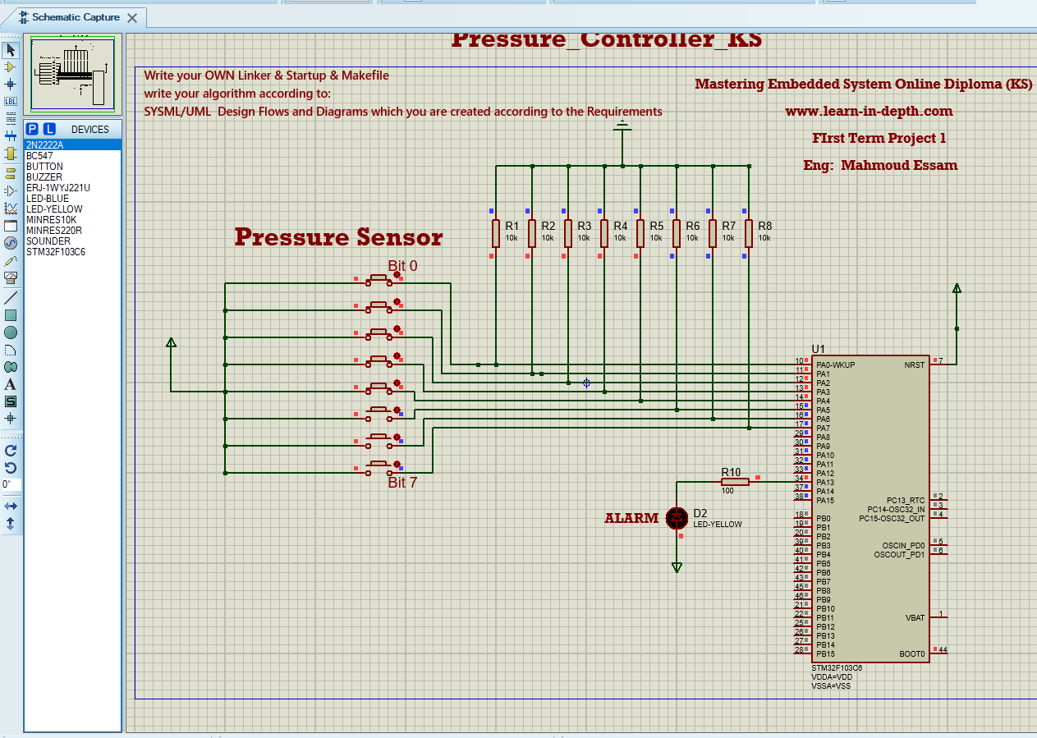

# **Code Screenshots**

## **Main.c**

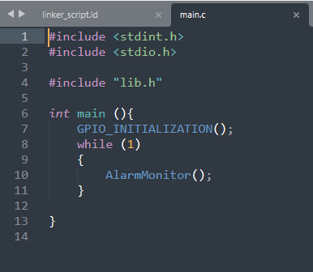

## **Lib.h**

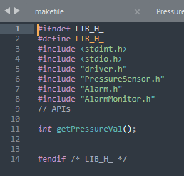

## **Alarm.c**

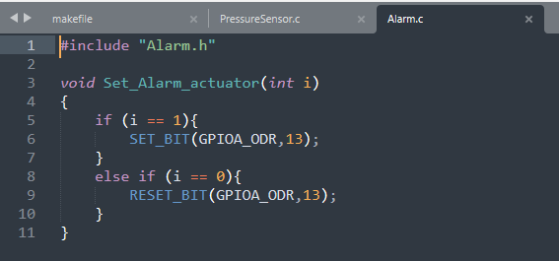

## **Alarm.h**

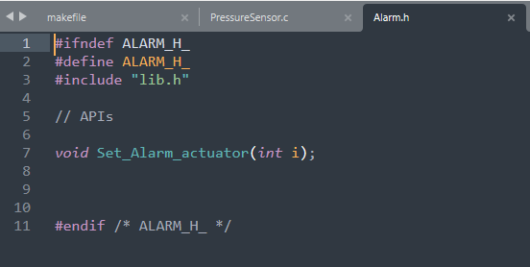

## **AlarmMonitor.c**

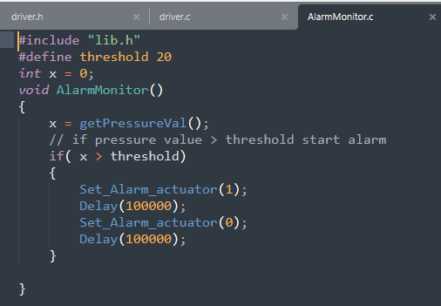

## AlramMonitor.h

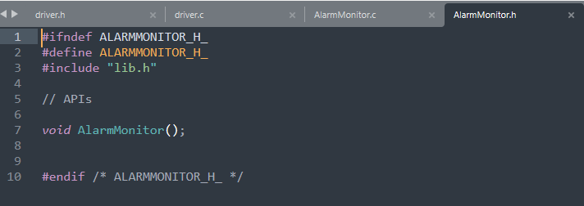

## **Driver.c**

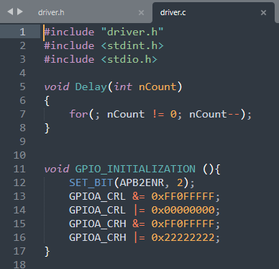

## **Dirver.h**

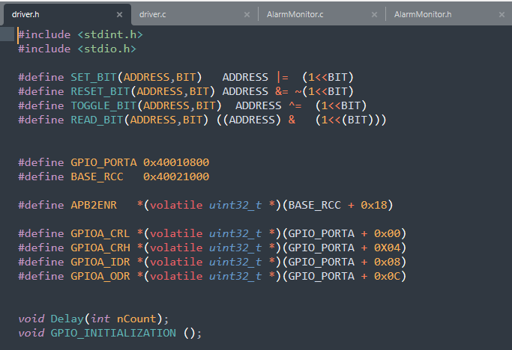

## **PressureSensor.c**

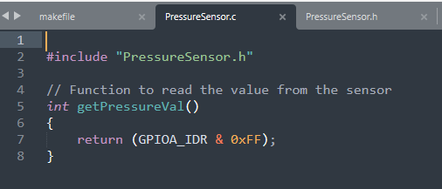

## **PressureSensor.h**

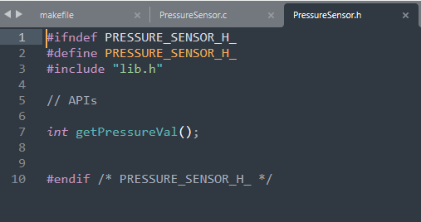

## **LinkerScript.ld**

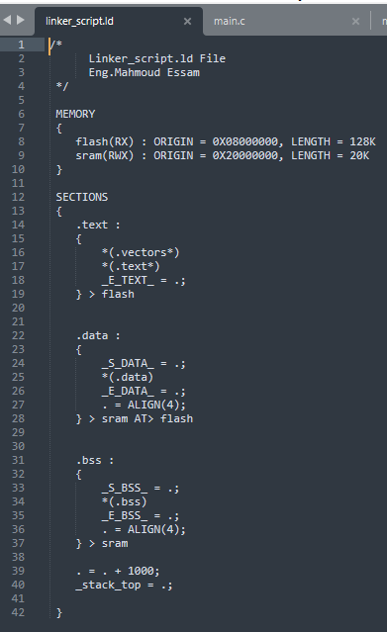

## **MakeFile**

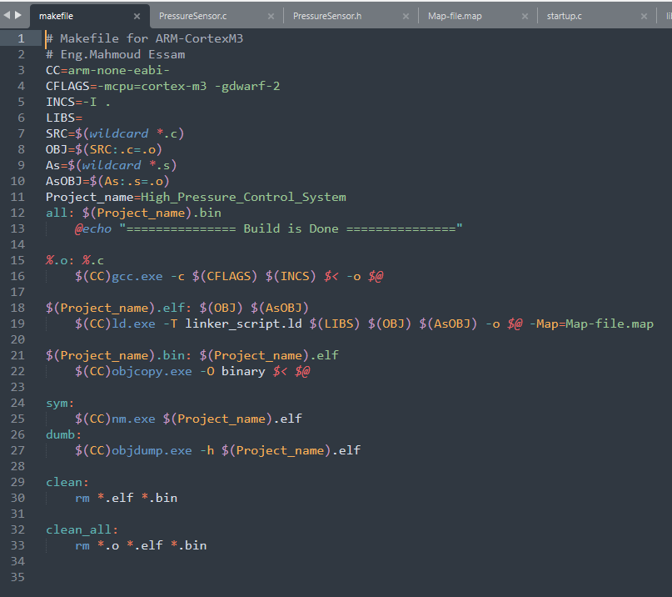

## **Startup.c**

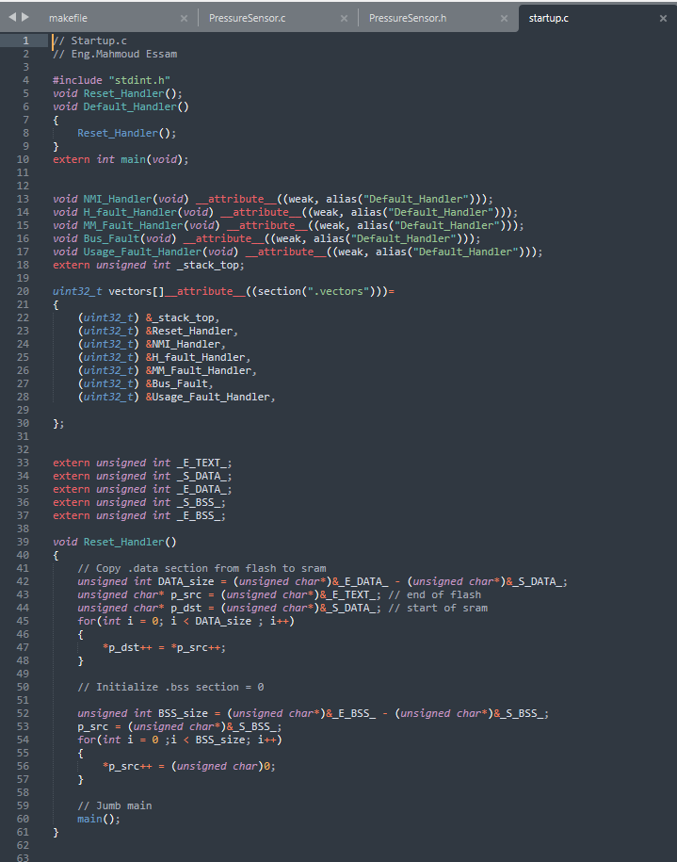

## **Sympols**

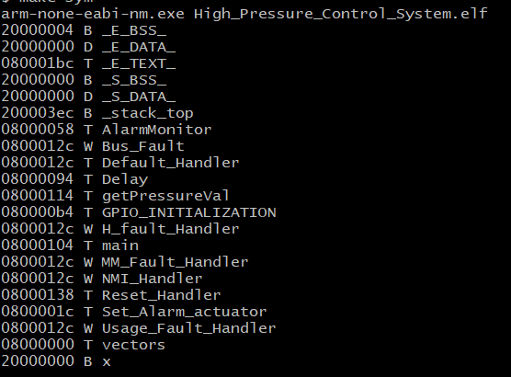

## **Code Sections**

